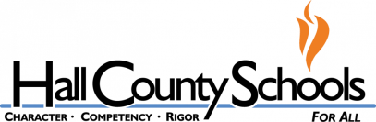
3265 Montgomery Dr.
Gainesville, Georgia 30504
770-534-7473
FAX 770-531-3055

Robin Reepe Gower, Program Director

2023-2024 Hall County Bright from the Start Dual Language Immersion Pre-K
What is Georgia's Pre-K Program? Georgia's Pre-K Program is a lottery funded educational program for Georgia's four year olds to prepare children for Kindergarten. Children four years of age on September 1 of the current school year who are Georgia residents are eligible to attend Georgia's Pre- K Program during this school year. Georgia’s Pre-K Program is voluntary for families and for providers.

What is does Dual Language Immersion? Dual language immersion is a form of bilingual education in which students are taught literacy and content in two languages. Our students are provided instruction ninety percent of the day in Spanish and ten percent of the day in English.
Locations:
Chicopee Woods Elementary School: https://forms.gle/hVQ1Kxr8CsXmEnzR6
Lyman Hall Elementary School: https://forms.gle/bc14qRwR9SWftFMRA
McEver Arts Academy: https://forms.gle/Yhmc2eRGG9PvGNLW8
Sardis Elementary School: https://forms.gle/5g1EzfXMS6VnBvSX7
Tadmore Elementary School: https://forms.gle/XiBmqEZPPpv2moYp6
White Sulphur Elementary School: https://forms.gle/Y8kaVw7kVqnAxqKh8
World Language Academy: https://forms.gle/sjCeJ8Gavxj9oyD89

Pre-K Application/Waiting List Form is available electronically. Please click the link beside each site you are interested in attending.
The Pre-K Lottery will take place on March 3rd at 10:00 am.
(We will continue accepting Pre-K Waiting List applications after the lottery, and will place the students on the site waiting list throughout the year.)
Pre-K Lottery Priority Acceptance List:
Pre-K Site Hall County Employees (employees that work on site where applying) Siblings (attending site where applying)
Hall County Employees (any site)
School Attendance Zone (does not apply to WLA-they do not have a school attendance zone) Hall County Residents
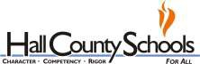
Students who live outside of Hall County, but in the state of Georgia.
We will hold two lotteries-Spanish and English to create a balance for our Dual-Immersion Pre-Ks.

Accredited by the Southern Association of Colleges and Schools

